**דף עבודה מספר 3**

**Ex1: NameCheck.c**

#pragma warning(disable:4996)

#include <stdio.h>

int main() {

char firstNameFirstLether, lastNameLastLetter;

printf("enter your first name first letter \n");

scanf(" %c", &firstNameFirstLether);

printf("enter your last name last letter \n");

scanf(" %c", &lastNameLastLetter);

if (lastNameLastLetter == firstNameFirstLether)

{

printf("they are the same letter");

}

else

{

printf("they are not! the same letter");

}

return 0;

}

**EX2: PriceCheck.c**

#pragma warning(disable:4996)

#include <stdio.h>

int main() {

int pB, pS, totalPrice; //Pb is the packages bought, and pS is packages sold

printf("enter the package amount you have bought: \n");

scanf(" %d", &pB);

printf("enter the package amount you have sold: \n");

scanf(" %d", &pS);

totalPrice = pS * 10 - pB * 5;

if (totalPrice > 0) {

printf("you gain money");

}

else if (totalPrice == 0) {

printf("you havent lost or gain money");

}

else

{

printf("you lost money");

}

return 0;

}

**Ex3: Arithmetic.c**

#pragma warning(disable:4996)

#include <stdio.h>

int main() {

double n1, n2;

char operasion;

printf("enter first number: \n");

scanf(" %lf", &n1);

printf("enter second number: \n");

scanf(" %lf", &n2);

printf("enter operasion: \n");

scanf(" %c", &operasion);

switch (operasion)

{

case '+':

printf("%lf + %lf = %lf", n1, n2, n1 + n2);

break;

case '-':

printf("%lf - %lf = %lf", n1, n2, n1 - n2);

break;

case '*':

printf("%lf * %lf = %lf", n1, n2, n1 * n2);

break;

case '/':

printf(" %lf / %lf = %lf", n1, n2, n1 / n2);

break;

default:

printf("Error! operator is not correct");

}

return 0;

}

**Ex4: SingleDigit.c**

#pragma warning(disable:4996)

#include <stdio.h>

int main() {

int n;

printf("enter number \n");

scanf(" %d", &n);

if (n < 10 && n > -10)

{

printf("the number is single digit");

}

else {

printf("the number isnt single digit");

}

return 0;

}

**Ex5: Qualify.c**

#pragma warning(disable:4996)

#include <stdio.h>

int main() {

int age, exp;

printf("enter your age \n");

scanf(" %d", &age);

printf("enter the number of your expirent years \n");

scanf(" %d", &exp);

if (exp >= 3 && age >= 35 && age <= 45) {

printf("you are qualify for this job, call us :)");

}

else {

printf("we are sorry :( you don't qualify for this job ");

}

return 0;

}

**Ex6: ArithmeticProgression.c**

#pragma warning(disable:4996)

#include <stdio.h>

int main() {

int n1, n2, n3;

printf("enter three numbers: \n");

scanf(" %d %d %d", &n1, &n2, &n3);

if (!((n2 - n1) - (n3 - n2))) {

printf("this is arithmetic progression");

}

else {

printf("this isn't arithmetic progression");

}

return 0;

}

**Ex7: Pythagoras.c**

#pragma warning(disable:4996)

#include <stdio.h>

int main() {

int n1, n2, n3;

printf("enter three numbers: \n");

scanf(" %d %d %d", &n1, &n2, &n3);

if (n1 > n2 && n1 > n3) {

if (!((n2 * n2 + n3 * n3) - (n1 * n1))) {

printf("this is pythagoras");

}

else

{

printf("this isn't pythagoras");

}

}

else if(n2 > n3) {

if (!((n1 * n1 + n3 * n3) - (n2 * n2))) {

printf("this is pythagoras");

}

else

{

printf("this isn't pythagoras");

}

}

else {

if (!((n1 * n1 + n2 * n2) - (n3 * n3))) {

printf("this is pythagoras");

}

else

{

printf("this isn't pythagoras");

}

}

return 0;

}

**Ex8: QuadraticEquationSolutionNumbers.c**

#pragma warning(disable:4996)

#include <stdio.h>

int main() {

double a, b, c, d;

scanf(" %lf %lf %lf", &a, &b, &c);

d = (b * b) - (4 * a * c);

if (!d) {

printf("there is one! sulotion");

}

else if (d > 0) {

printf("there is two! sulotion");

}

else {

printf("there is no sulotion!!!");

}

return 0;

}

**Ex9: SumOrMulti.c**

#pragma warning(disable:4996)

#include <stdio.h>

int main() {

int n1, n2, n3, sum, multi;

printf("entre three numbers: \n");

scanf(" %d %d %d", &n1, &n2, &n3);

multi = n1 * n2 * n3;

sum = n1 + n2 + n3;

printf("multiplicasion of this numbers equal: %d \n", multi);

if (sum < multi) {

printf("numbers sum is: %d \n", n1 + n2 + n3);

}

else {

printf("the numbers are: %d,%d,%d \n", n1, n2, n3);

}

return 0;

}

**Flowchart:**

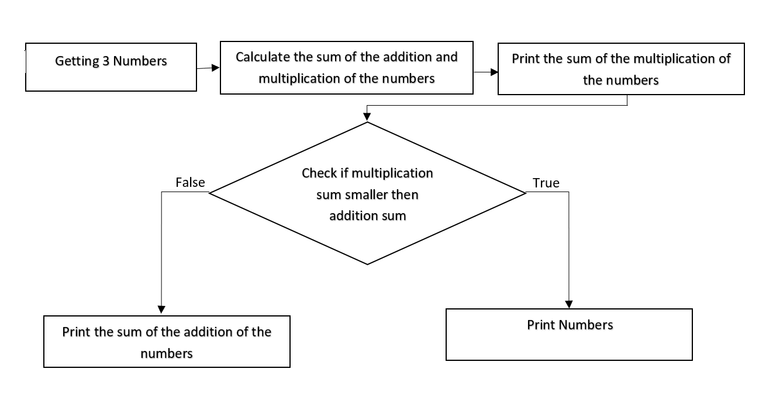

Ex 10:

A = 5

B = 8

C = -3

D = 0

1. False
2. True
3. False
4. True
5. True